**A**

**B**

**T/L**

**TOT**

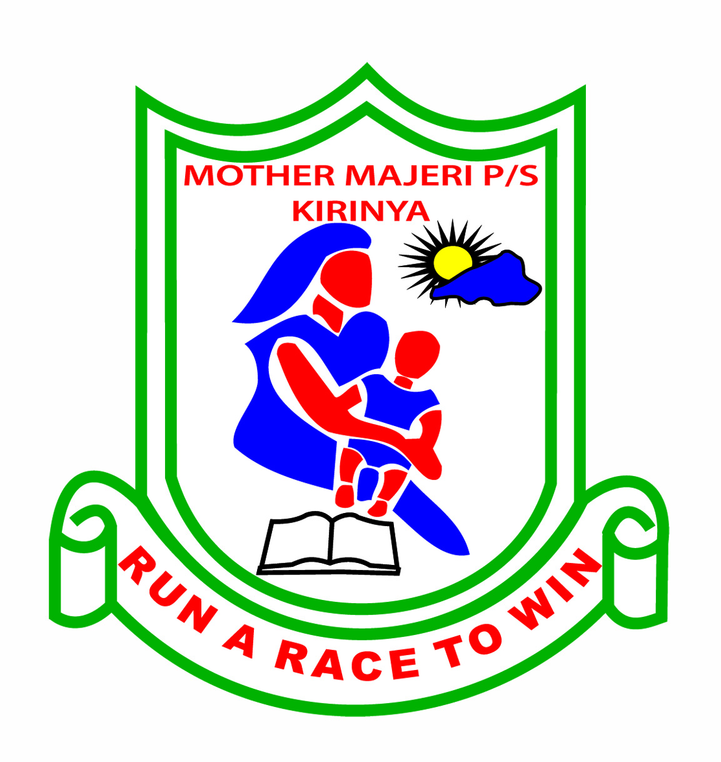**MOTHER MAJERI PRIMARY SCHOOL**

**END OF TERM II EXAMINATION, 2024**

**CLASS : P.1**

# SUBJECT : READING

# DURATION : 2 HOURS & 15 MINUTES

**Name ___________________________________________________________**

**Stream______________________**

**SECTION A (60 MARKS)**

1. **Sound the syllables to your teacher correctly.**

pi sta mi ce nva

cha go dre mpi ca

2. **Read these words of ‘—ad-‘family.**

mad lad sad dad glad

3. **Read the tricky words correctly.**

you here of are we

4. **Read and sound these words with silent letter “w”.**

write wrist wrong wrap wrinkles

5. **Read these sentences aloud to teacher.**

a) it is a windy day

b) The man is sad.

c) Lions eat a lot of meat.

d) A pig has a hat.

e) I can see a big bus.

**SECTION B( 40 MARKS)**

**Read the story below sounding the words correctly.**

We went to the zoo. But it was a rainy day. So, I put on my gumboots and my book was in the bag. At the zoo, we saw a zebra, a goose and many other things I love touring.